Unit 5  Unit 7 | The Wonderful Solvent – Water  Living Things and Air
Topic: Man-made dead zones in aquatic environments
Name: ____________________
Class: __________________( )
Date: _______________________

How do wastes of human activities create dead zones in aquatic environment?

Collect water from pond or stream with a large clean bottle (e.g. 2 L plastic bottle).  Note: Water should be obtained from a safe water source. | 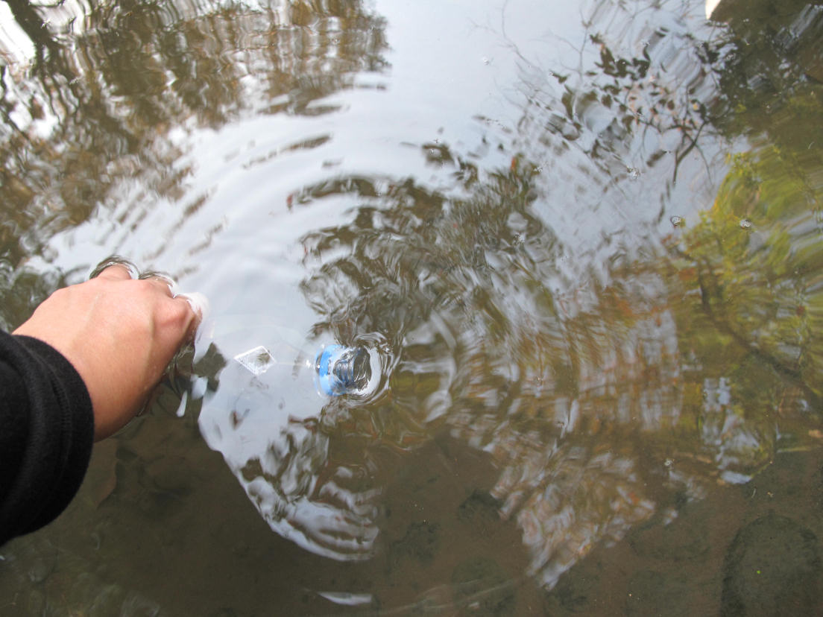  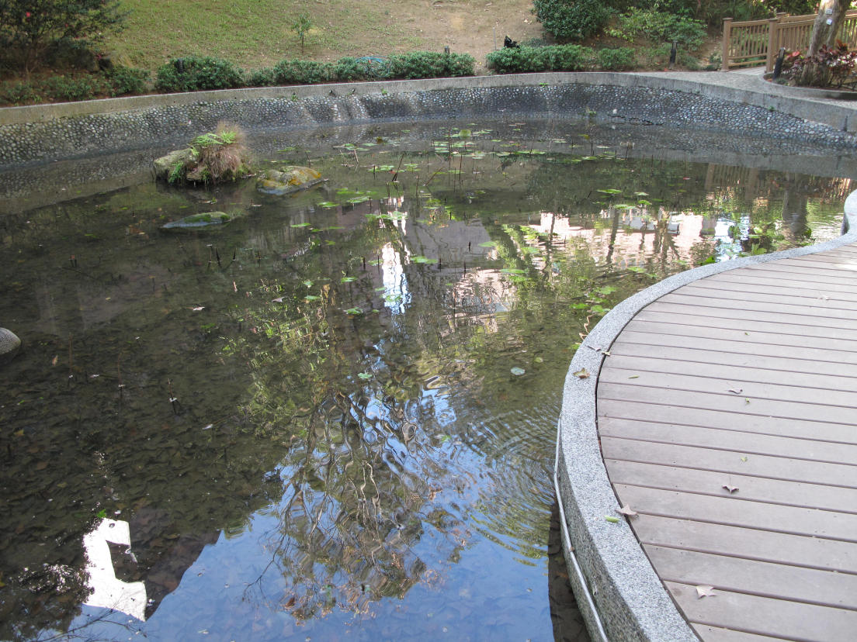

Label three identical jars (or bottles) respectively as  “Tap water” (or “Distilled water”);  “No nutrient” and;  “Fertilizer” | 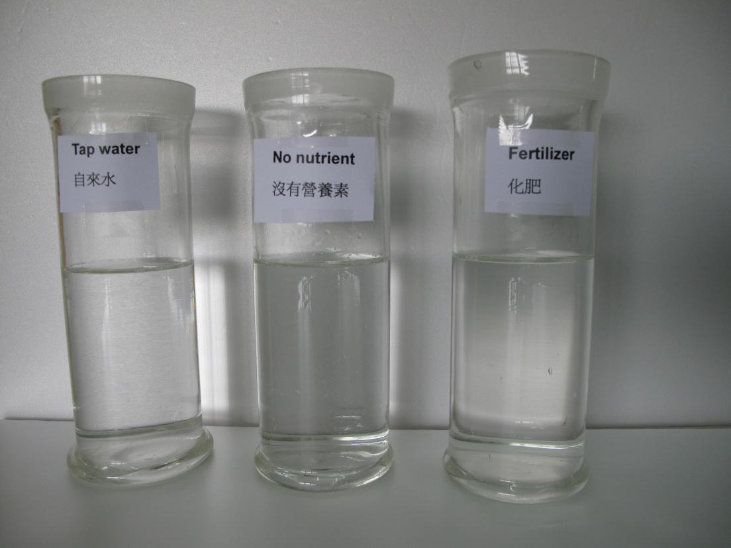

For each of the jar, fill in the same volume of the following liquids accordingly:
Jar label | Liquid to be filled in
Tap water (or Distilled water) | Tap water or distilled water
No nutrient | Collected pond or stream water
Fertilizer | Collected pond or stream water

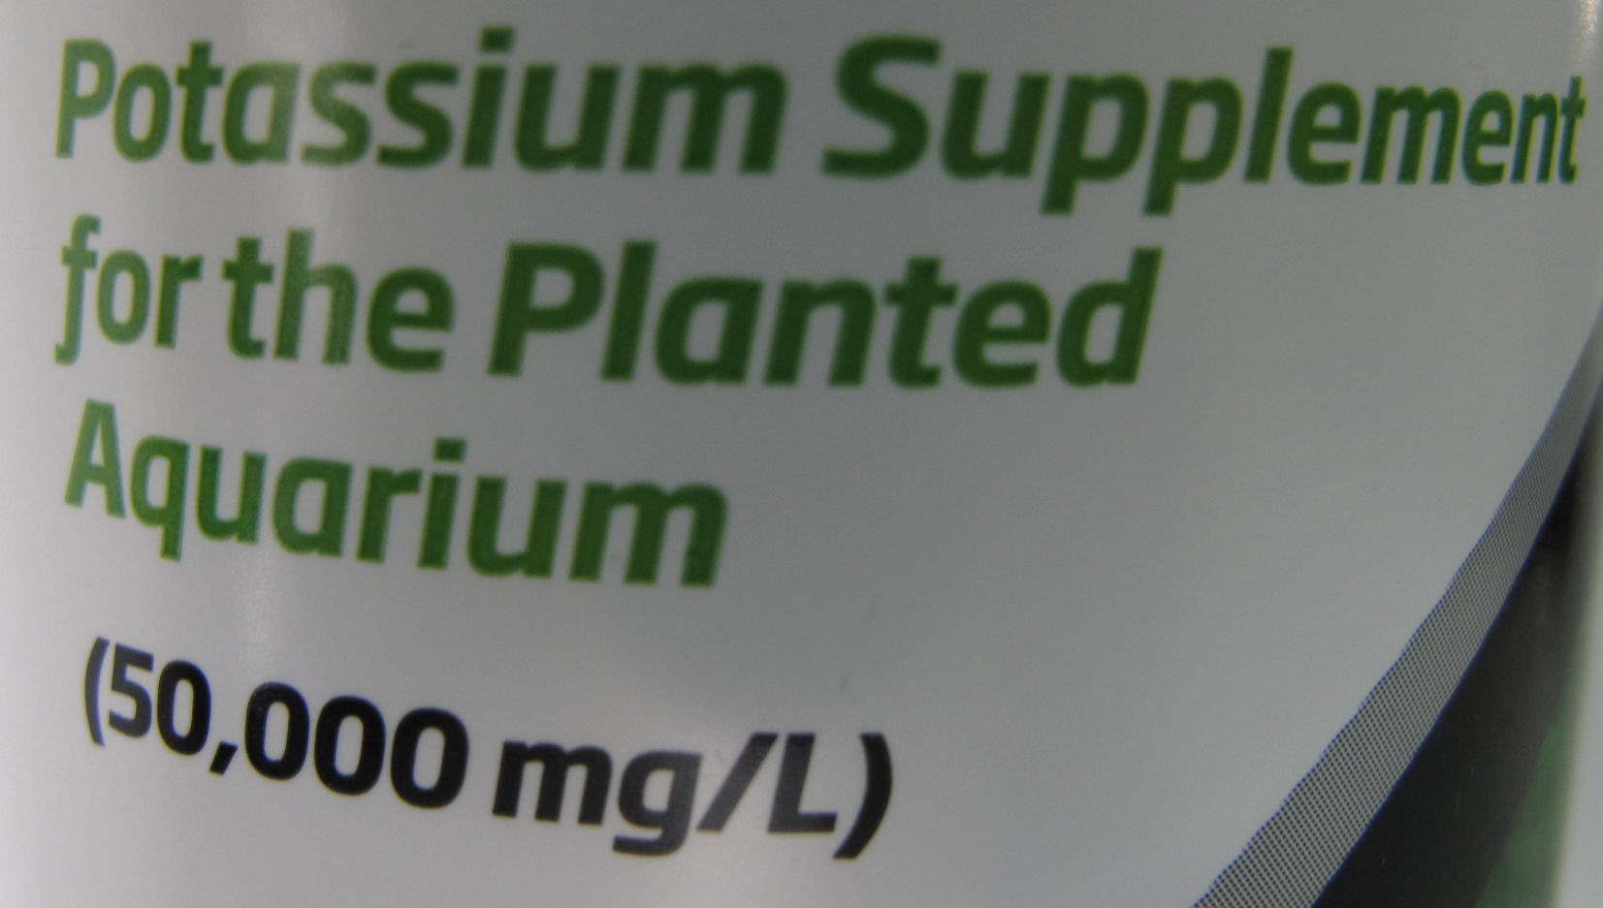
For the jar labeled as “Fertilizer”, add 100 mg of fertilizer into it and stir thoroughly.
1. If the fertilizer that you are going to use is a liquid, calculate the amount (in ml) of fertilizer to be added according its concentration.
For example, the concentration of potash shown in the diagram is 50000 mg / L.
To add 100 mg of fertilizer, the amount of potash to be used is
(100 mg / 50000 mg / L) × 1000 mL = 2 mL

PART (A)

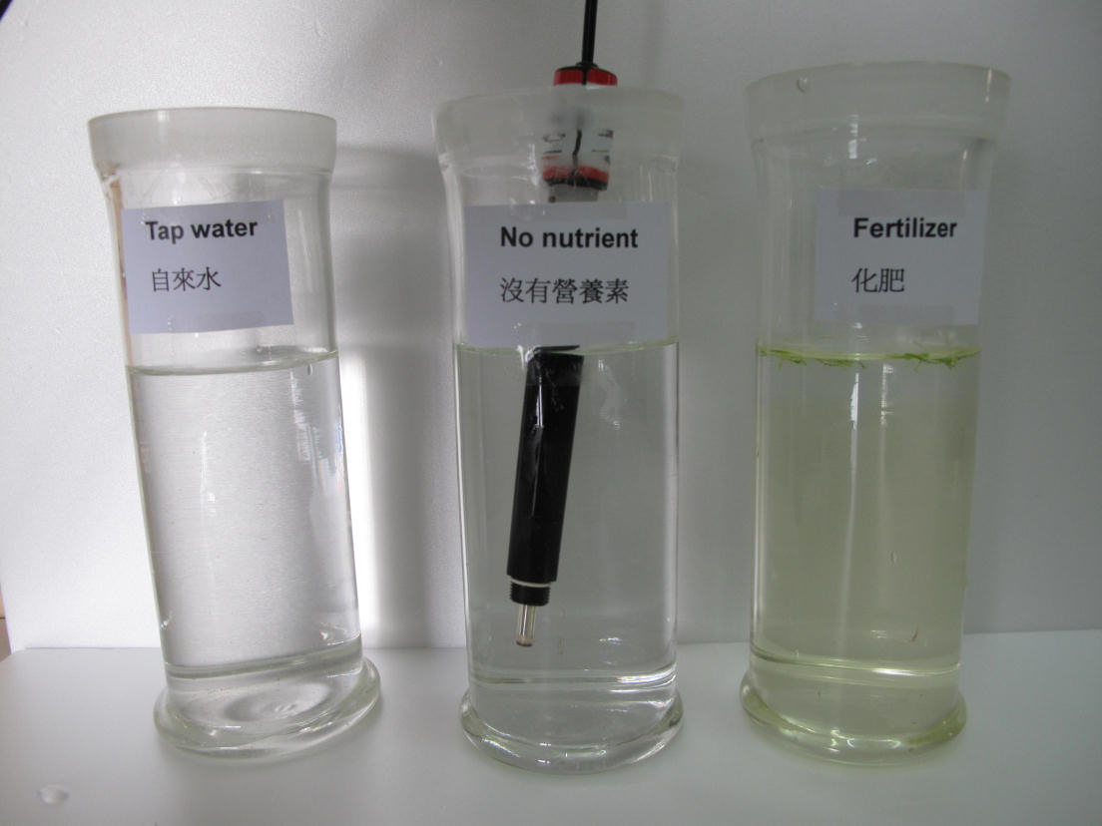
Leave the opening of each jar open and then place all jars under sunlight for five to seven days. The jars can be placed by a sunlit window or on an open roof top.

Record observations of the jars at the same time (e.g. at noon) every day, such as the colour of water inside the jar and the smell, and measure the concentration of dissolved oxygen in water with a probe of an oxygen sensor.

Remarks:
Leave the jars under sunlight for a few more days if there are no significant differences between the water in the jars. It may be caused by several cloudy days during the investigation.

2. What is the unit of the reading of concentration of dissolved oxygen measured by the oxygen sensor that you use? ___________

Record the concentration of dissolved oxygen in water at time ________
Day
Jar
Tap water
No nutrient
Fertilizer
Record the colour of water at time ________
Day
Jar
Tap water
No nutrient
Fertilizer

Record the smell of water at time ________
Day
Jar
Tap water
No nutrient
Fertilizer

PART (B)
After five days (or when you see that there is an algal bloom in the jar labeled “Fertilizer”), | 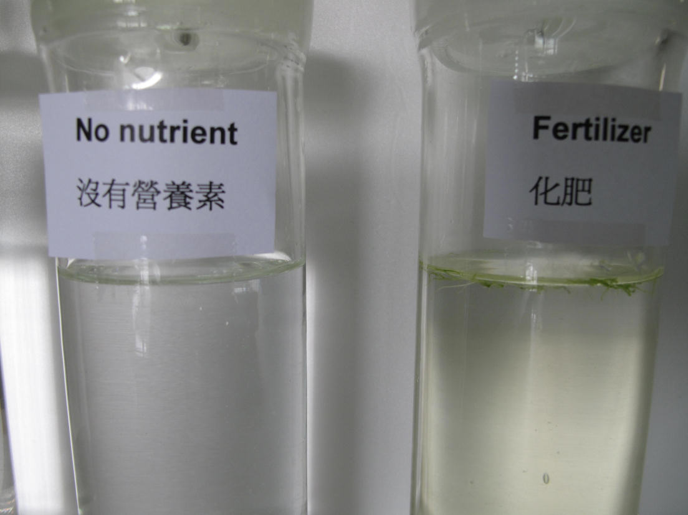
put all jars, with the openings tightly closed with a cover, in a dark place for two to three days. | 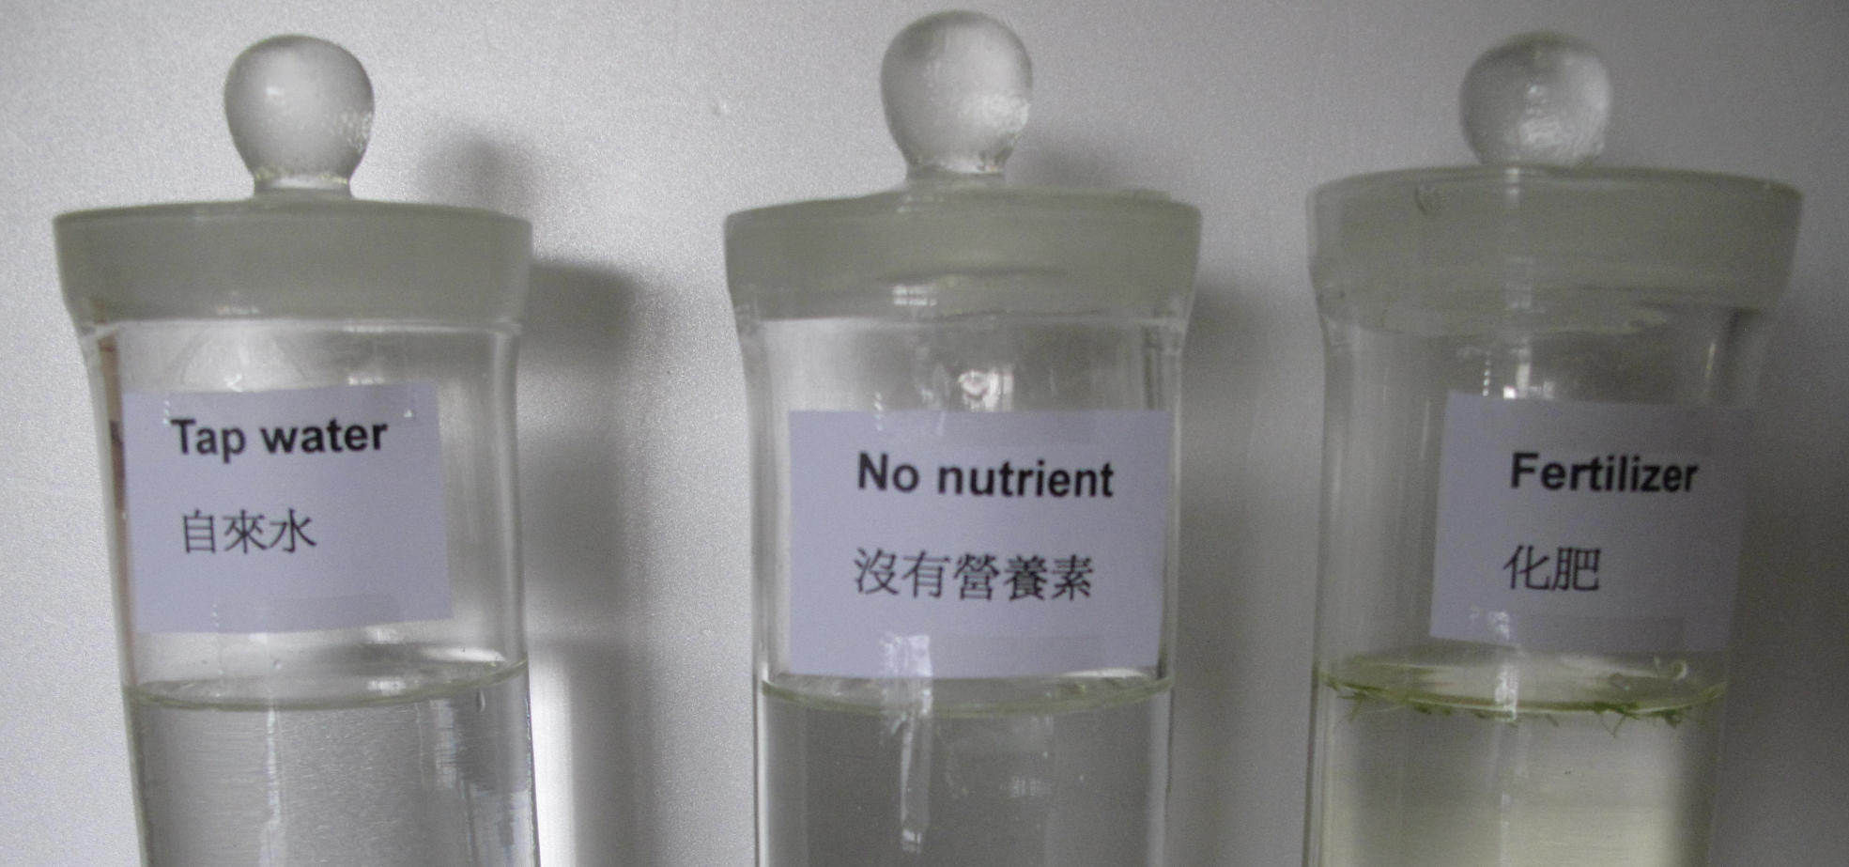

Record the concentration of dissolved oxygen in water at time ________
Day
Jar
Tap water
No nutrient
Fertilizer

Record any significant observations inside the jars with descriptions.

Plot a graph of measured concentration of dissolved oxygen in water inside the three jars against time in both PART (A) and PART (B) with suitable scales on the same graph. Indicate the part of the graph when the jars were placed in a dark place.

Jars are placed in dark place

3. With reference to the graph, describe and explain the trends of oxygen concentration of the liquids inside the jars when they are placed under sunlight.
Phytoplankton in collected pond water grew through photosynthesis when the jars were
placed under sunlight.
Phytoplankton grew much more (as algae bloom was observed) in the jar labeled
“Fertilizer” as excessive nutrient (fertilizer) was provided. Hence, concentration of
dissolved oxygen in water significantly increased due to photosynthesis in the jar labeled
“Fertilizer”. Eventually there was an algal bloom in this jar.

4. With reference to the graph, describe and explain the trends of concentration of oxygen in water inside the jars when they were placed in a dark place.
When the jars were placed in a dark place, phytoplankton died in the absence of
photosynthesis. They then sank to the bottom and they were decomposed by bacteria in a
process that consumed oxygen.
For the jar labeled “Fertilizer”, a much larger amount of phytoplankton died.
Therefore, bacteria in water consumed much more oxygen to decompose the dead
phytoplankton. Hence, concentration of dissolved oxygen in water decreased so sharply
that a dead zone was developed.

5. What is the purpose of jars labeled “Tap water” and “No nutrient”?
The jars labeled “Tap water” and “No nutrient” are used as control. Phytoplankton
also existed in these two jars, but no fertilizer was added.

6. What conclusion(s) can be drawn from this investigation?
The use of nutrient (e.g. fertilizer) leads to excessive growth of plants in aquatic
environment. When large amount of plants die, they sink to the bottom and they are
decomposed by bacteria in water that consumes a large amount of oxygen. Dead zones
are then developed as there is a significant depletion of oxygen in water.

